**Sssaaaaaaaaaaaaaaaaaaaaaaaaaaaaaaaaaaaaaaaaaa**

**INDIAN EV MARKET SEGMENTATION ANALYSIS**

**Pratiksha Nakate**

**21 May, 2024**

**Github Link:**  <https://github.com/nakatepratiksha/nakatepratiksha>

**Overview:**

This report outlines a strategic roadmap for our Electric Vehicle Startup's entry into the Indian market. Through segmentation analysis, we target key customer segments based on geographic, demographic, psychographic, and behavioral factors. We prioritize regions conducive to early EV adoption and devise a pricing strategy tailored to early adopters' preferences. Despite data limitations, our approach ensures accurate decision-making. The goal is to establish a strong foothold in the Indian EV market by capitalizing on emerging trends and consumer preferences.

**Market Overview:**

Despite facing challenges such as infrastructure constraints and initial high costs, the EV market in India is poised for exponential growth.The market segmentation analysis reveals diverse consumer segments characterized by geographic, demographic, psychographic, and behavioral factors. Urban areas with higher income levels, tech-savvy populations, and environmental consciousness emerge as key target segments for EV adoption.

Strategic pricing considerations take into account the early adopter psychographics, competitive landscape, and value proposition of EVs. By offering competitive yet profitable pricing ranges, EV startups can capture the imagination of early adopters while ensuring sustainable growth.

While data availability poses challenges, alternative research methodologies ensure accurate decision-making. Leveraging insights from the Innovation Adoption Life Cycle, startups can identify regions at different stages of EV adoption and tailor their market entry strategies accordingly.

**1.1. Segmentation Analysis:**

**a. Geographic Segmentation:**

Analysis of EV registrations across different states/UTs reveals geographical trends in adoption.

States with higher total vehicle registrations and a higher percentage of electric vehicles indicate better market potential.

**b. Vehicle Type-wise Segmentation:**

Segregating EV registrations based on vehicle types (two-wheeler, three-wheeler, four-wheeler, etc.) provides insights into segment-specific preferences.

Market potential varies across vehicle types, with certain segments showing higher adoption rates.

**c. Charging Infrastructure Segmentation:**

Evaluation of charging station distribution across states and highways helps identify regions with better infrastructure support for EVs.

Areas with a higher number of sanctioned EV charging stations offer better market access.

**d. Consumer Segmentation:**

Analysis of consumer reviews and preferences provides insights into target customer demographics, usage patterns, and satisfaction levels.

Factors such as visual appeal, reliability, performance, and value for money influence consumer purchasing decisions.

1. **2 Market Entry Strategy:**

**a. Target Segments:**

Based on segmentation analysis, target segments with high EV adoption rates, favorable infrastructure, and positive consumer sentiment.

Prioritize segments with a growing market share and untapped potential, such as urban areas with high population density and rising environmental awareness.

**b. Product Offering:**

Develop a diverse product portfolio catering to different segments, including two-wheelers, three-wheelers, and four-wheelers, with varying price points and features.

Emphasize key product attributes such as battery capacity, drive range, charging time, and performance to meet diverse customer needs.

**c. Distribution and Infrastructure:**

Establish strategic partnerships with local dealerships, distributors, and charging infrastructure providers to ensure widespread availability and accessibility of EVs and charging stations.

Invest in building a robust charging infrastructure network in target regions to alleviate range anxiety and enhance consumer confidence.

**d. Marketing and Promotion:**

Implement targeted marketing campaigns focusing on the unique benefits of EVs, such as lower operating costs, reduced environmental impact, and government incentives.

Leverage digital platforms, social media, and influencer marketing to reach and engage with target demographics effectively.

**Data Pre-processing:**

1. Handle Missing Values:

- Identify and address any missing values in the dataset by either imputing them or removing the corresponding rows/columns.

2. Remove Duplicate Entries:

- Check for and eliminate any duplicate rows to maintain data integrity.

3. Convert Categorical Variables:

- Encode categorical variables into numerical format using techniques like one-hot encoding or label encoding.

4. Normalize/Scale Numerical Features:

- Scale numerical features to a similar range to improve model performance, if necessary.

5. Feature Engineering:

- Create new features from existing ones if they provide additional insights for analysis.

6. Handle Outliers:

- Identify and handle outliers in the dataset using appropriate techniques such as removal or transformation.

7. Data Formatting:

- Ensure that the data is formatted correctly and consistently for analysis.

By performing these preprocessing steps, the electric vehicle market data will be cleaned, standardized, and ready for segmentation analysis or any other form of analysis.

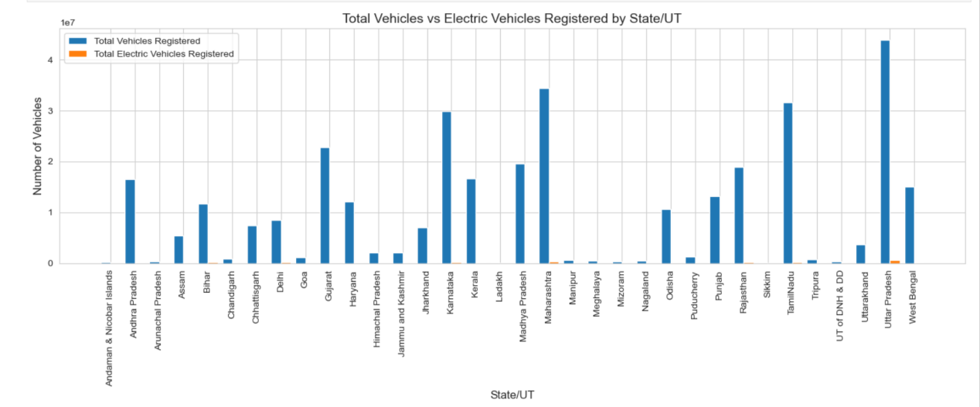

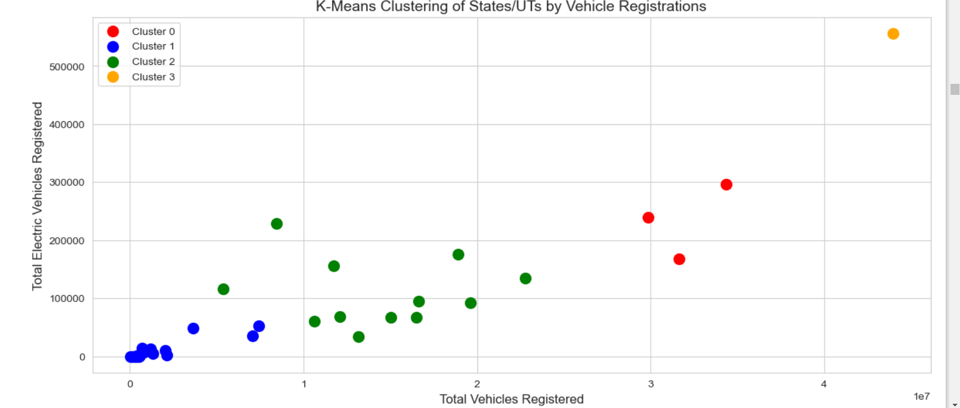

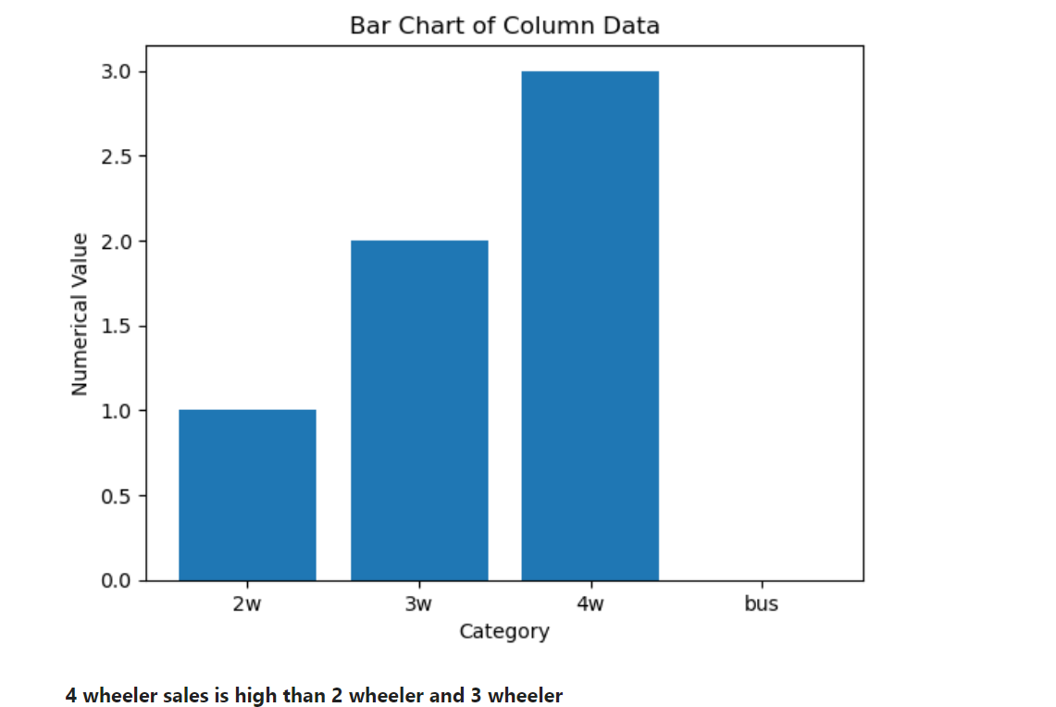

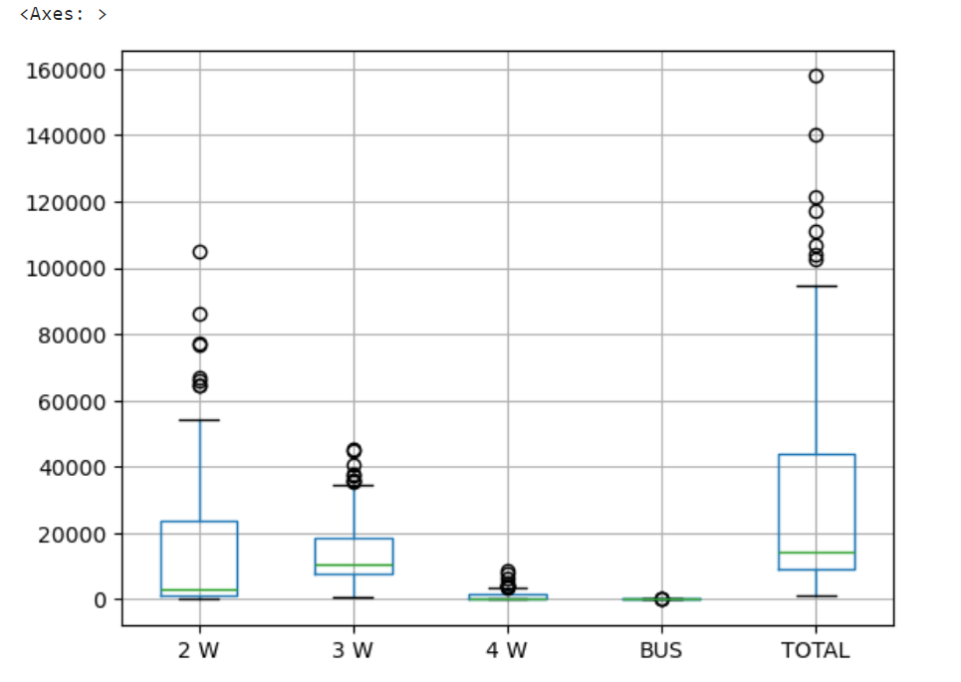

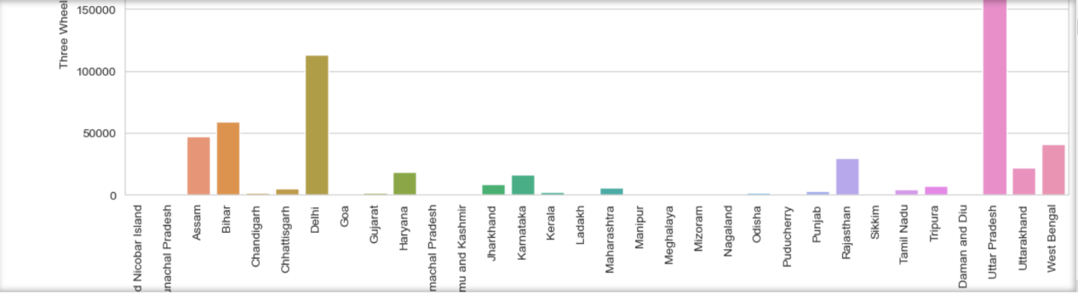

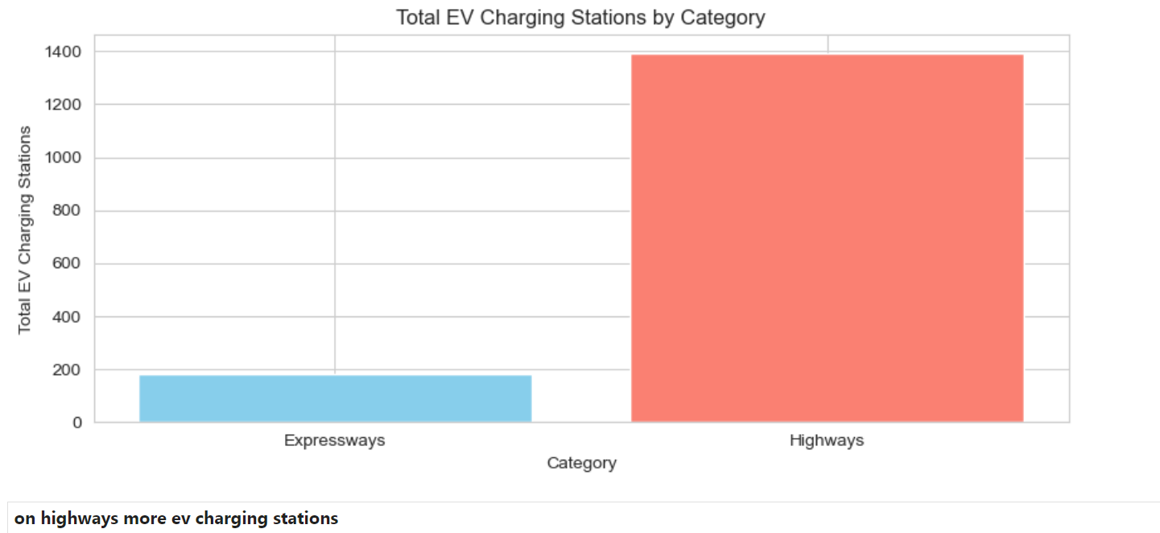

Conclusion:

The electric vehicle market in India offers significant opportunities for growth and innovation. By leveraging segmentation analysis and adopting a strategic market entry approach, companies can effectively target and capture promising segments, driving sustainable growth and contributing to the advancement of the EV ecosystem in India.